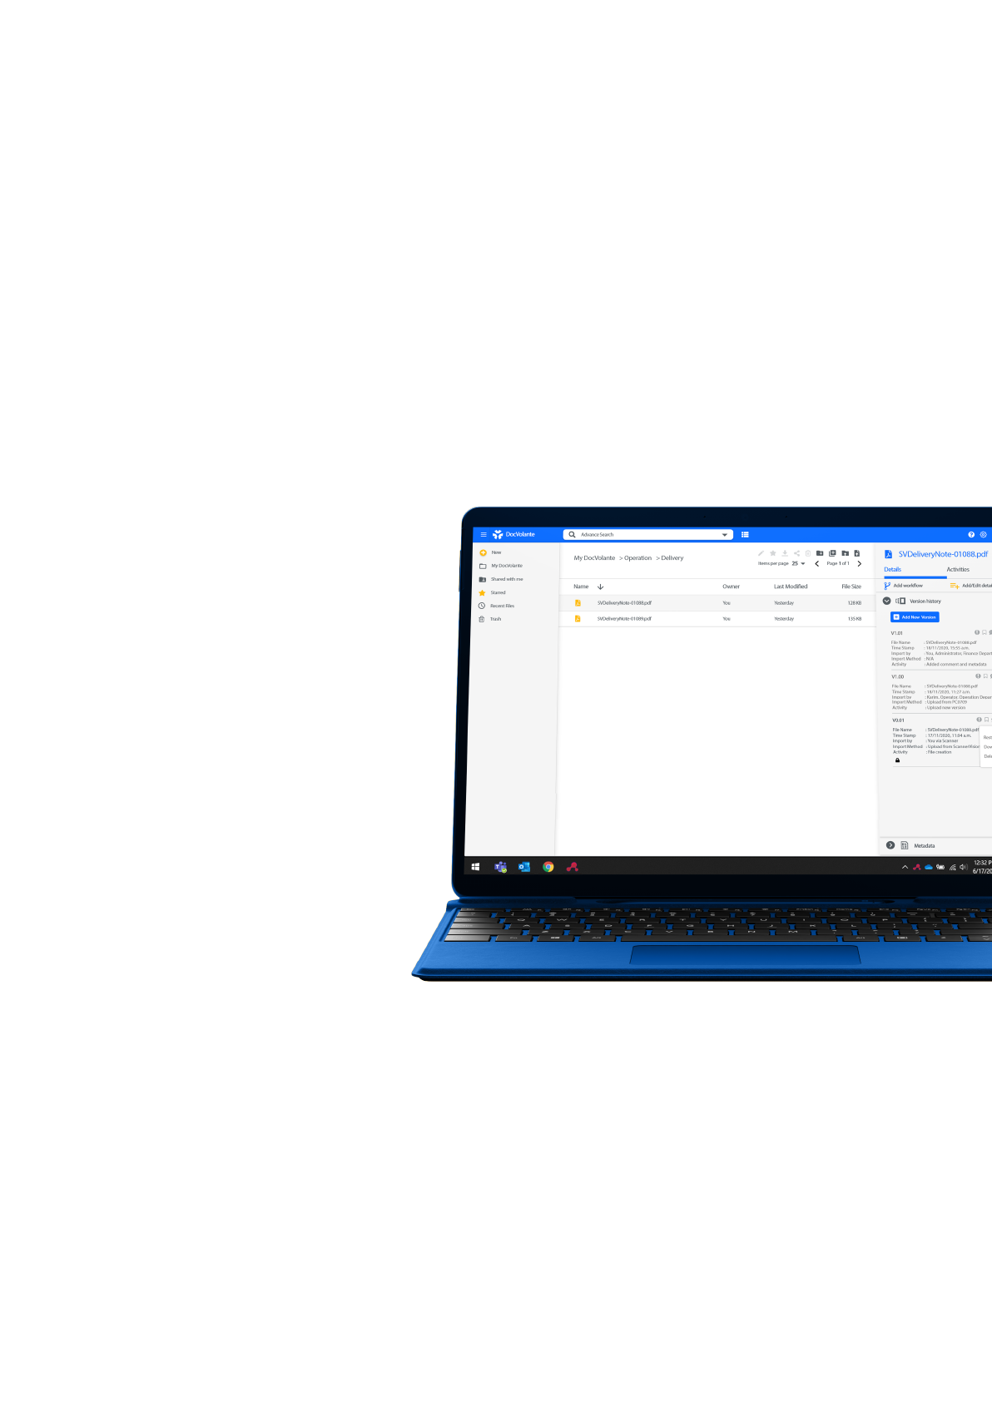
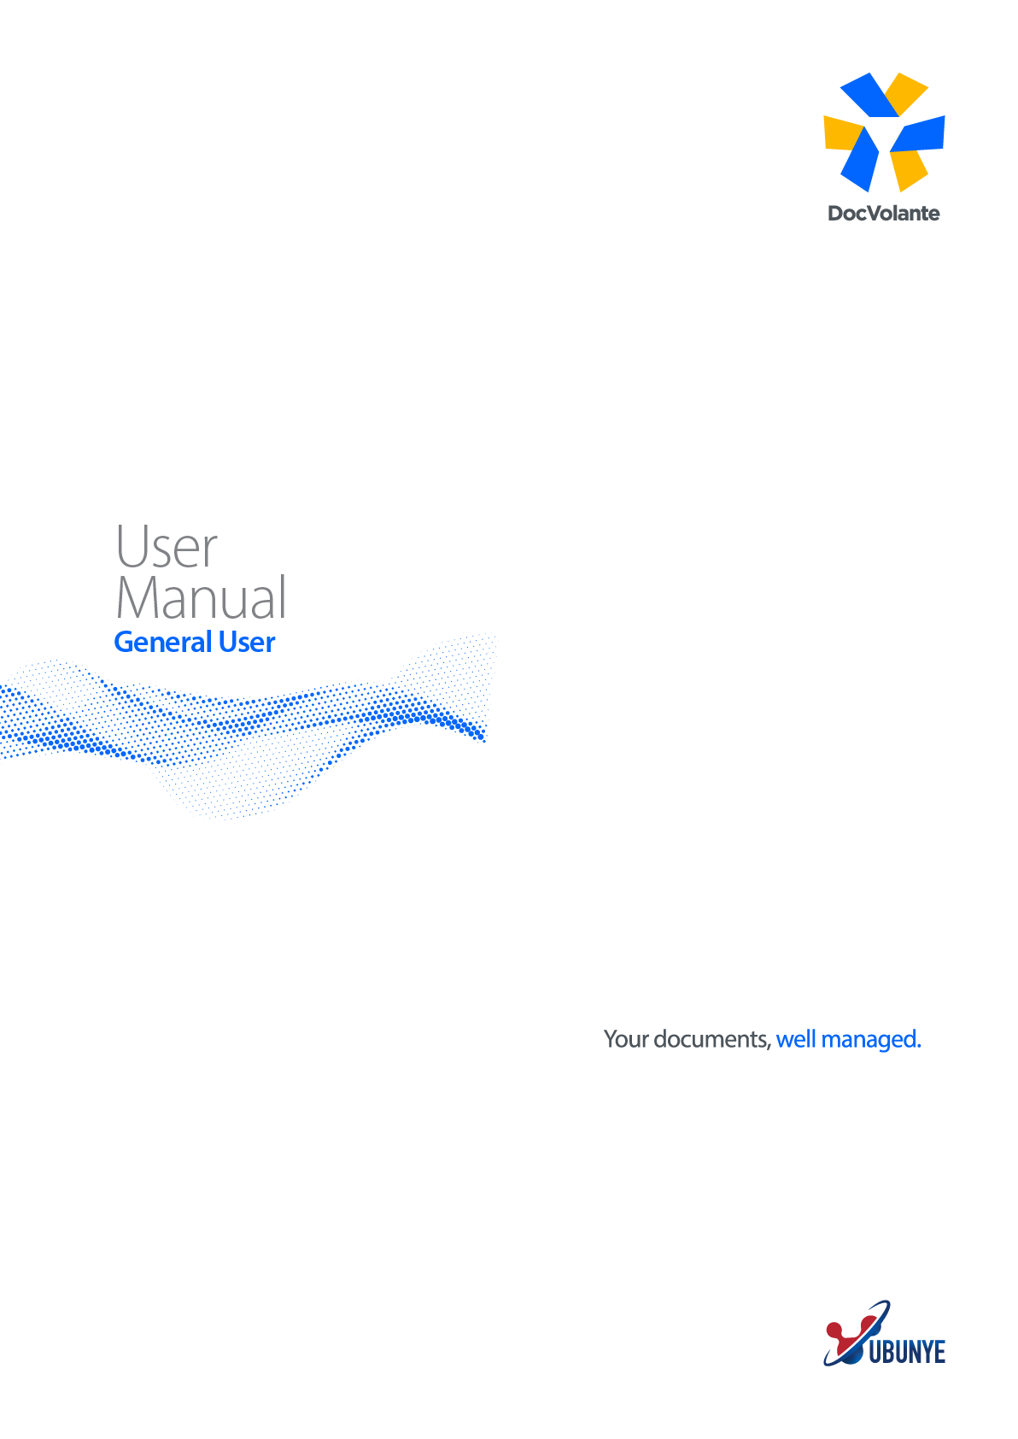

Login Page

The DocVolante log-in page has a very familiar layout.

Step 1:
In the Username section enter your Username.

Step 2:
In the Password section enter your Password.
DocVolante can also be integrated with Active Directory and LDAP.

Step 3:
By Selecting the eye symbol in the password field, your password will be revealed.

Step 4:
By Selecting the eye symbol in the password field again, your password will be hidden.

Step 5:
Click on Sign In to access DocVolante

Navigation Panel

In the Navigation panel on the left My DocVolante with a drop-down arrow is displayed.
There are many ways that you can use the Navigation Panel based on your user preference.
- The User Folder is an area that only you can access. No-one else can see the files here and every user has their own unique User Folder area.
- My Libraries is where a user can store and manage content, such as documents, images, and videos.
You can upload content to share with other users. Users can view and work on this content depending upon their permission settings.
- Public Libraries is a library that the user has created under My Libraries. When creating the library, the user has the option to select whether the user wishes to make the library, Private, Public or Moderate.
- Public Shared is a unique area where you can store and share content, without adding it to a Document Library. You can quickly share a document with a colleague or colleagues depending on the allowed permissions.

Shared Links – reflects all the documents that has been shared outside of DocVolante via a Shared link within the organisation.
Starred – reflects all the users favourite files and documents they work with on a regular basis.
Recent files - reflect all the latest files that has been brought into the system or worked on in DocVolante.
Recycle Bin - is DocVolante’s Recycle Bin where all deleted files are kept.

My DocVolante
Creating a folder Manually

Step 1:
Select My DocVolante & User Folder.
Note the top menu bar reflects you are in My DocVolante (immgartc), User Home and the user logged in.

Step 2:
Select the New Folder option from the top menu bar.

Step 3:
Complete the following New Folder information fields:
- Name
- Title
& Select CREATE.

Upload File

Step 1:
When uploading a document or documents, select the Folder (Invoice Folder) you wish to upload the documents too.

Step 2:
Select the Upload File option from the top menu bar.

Step 3:
Browse windows file explorer and select the document or documents you wish to upload.

Step 4:
Once you have selected the documents you wish to upload, click OPEN.

Step 5:
A status bar will appear at the bottom right-hand corner of the screen showing the documents have successfully been uploaded.

Step 6:
Select the Close button on the bottom right-hand corner of the status bar to complete the Upload.

Drag & Drop

Step 1:
Minimize the DocVolante pane.

Step 2:
Open the folder you wish to drag and drop you document into.

Step 3:
Open and minimize the Windows file folder you wish to drag you document or documents from.

Step 4:
Click and drag you document from the Windows pane and drop it into the DocVolante folder you have open.

Step 5:
A status bar will appear at the bottom right-hand corner of the screen showing the document has successfully been uploaded.

Step 6:
Select the Close button on the bottom right-hand corner of the status bar to complete the Upload.

Managing
Document Types
(Method 1)

When managing your document types manually it is important to remember it can be managed in two different ways.

Step 1:
Select the folder for example the Invoice folder.

Step 2:
Select the document you wish to assign the Document Type too.

Step 3:
Right click on the document and select Manage Document Type.

Step 4:
Click on the Add Document Type drop down menu.

Step 5:
Select from the drop-down menu the document type you wish to assign to the document for example invoice.

Step 6:
If you do not wish to add a Document Type via this method, click outside the selection menu and select the document again.

Step 7:
Once the document has been selected, move your cursor to the yellow information panel on the right-hand side of the screen and click.

Step 8:
A yellow Add/Edit detail drop down screen will appear.

Step 9:
Select from the drop-down menu the document type you wish to assign to the document for example invoice.

Step 10:
Once you have selected the document type Invoice, a drop-down menu with template fields will appear.

Step 11:
On the top left-hand corner of the information panel click on the document type button. This will move the document into the workspace for the user to view the information required to complete the template fields.
Complete the following template fields associated with the Invoice.
- File Name
- Due Date
- Account Number
- Customer Name
- Amount Due
- Invoice Number
- Date

Step 12:
Once the metadate fields has been completed, click on ADD to complete the process.

Step 13:
To confirm the information is correct you can select Add/Edit details again for a quick overview.

Step 14:
On the information panel you can also navigate to the Metadata heading. Here all the metadata you have entered will be displayed.
Additional information is displayed such as:
- Creator
- Date the document was brought in the system.
- Document Type
- File Size

Managing
Document Types
(Method 2)

When managing your document types manually it is important to remember it can be managed in two different ways.

Step 1:
Select the folder for example the POD folder.

Step 2:
Once the document has been selected, move your cursor to the yellow information panel on the right-hand side of the screen and click.

Step 3:
A yellow Add/Edit detail drop down screen will appear.

Step 4:
Select from the drop-down menu the document type you wish to assign to the document for example delivery note.

Step 5:
Once you have selected the document type delivery note a drop-down menu with template fields will appear.

Step 6:
On the top left-hand corner of the information panel click on the document type button. This will move the document into the workspace for the user to view the information required to complete the template fields.
Complete the following template fields associated with the Delivery Note.
- File Name
- Amount Due
- Delivery Address
- Customer Name
- Date
- Order Number
- Supplier

Step 7:
Once the metadate fields has been completed, click on ADD to complete the process.

Step 8:
To confirm the information is correct you can select Add/Edit details again for a quick overview.

Step 9:
On the information panel you can also navigate to the Metadata heading. Here all the metadata you have entered will be displayed.
Additional information is displayed such as:
- Creator
- Date the document was brought in the system.
- Document Type
- File Size

Managing Comments

Step 1:
Select the folder you wish to work with for example the Invoice folder.

Step 2:
Select the document you want add comments too.

Step 3:
Select the yellow information panel on the right-hand side of the screen.

Step 4:
A quick view of the document metadata can be done by selecting Add/Edit details.

Step 5:
On the information panel you can navigate to the Comments section. Here you can add any comments associated to the Invoice you have brought into the system.

The benefit of adding comments associated to a document is that they can act as a reminder to the user working with these documents daily.

Versioning &
Document History

Documents are versioned in a Major & Minor version format. When a document itself is replaced with a new version the major version number is incremented. When the metadata of the document is updated, the minor version is updated.

(Creating a Minor Version)

Step 1:
Select the folder you wish upload.

Step 2:
Select the document you want add comments too.

Step 3:
Select the document and go to Add/Edit details and complete the metadata associated with the document.

Step 4:
Click on ADD to save the completed metadata.

Step 5:
Below the ADD/Edit details option on the Information panel, the option Version history reflects.
Select Version history.

Step 6:
Version histories show the following:
- – When the document was originally brought into the system.
1.1 – When the metadata was added to the document – this reflects as a minor version in DocVolante.

(Creating a Major Version)

Step 1:
Select the document you wish to make changes too.

Step 2:
Right click on the document and select the option Check out document.

Step 3:
The document will now be checked out to the downloads folder.

Step 4:
The user can now open the document in its native format and make the necessary changes.

Step 5:
Once the necessary changes have been made the user will save the document in their folder of choice or back into the downloads folder.

Step 6:
From inside DocVolante, select the same document again, right click on the document and the select the Check in document option.

Step 7:
On the Information panel Version history option appears. Select Version history.

Step 8:
Version histories show the following:
1.0– When the document was originally brought into the system.
1.1 and so on – When the metadata was added to the document – this reflects as minor versions in DocVolante.
2.0 – When the document was checked out of the system and checked back into the system. This is considered a major version change in DocVolante.

Auditable

A detailed audit trail is kept of a document from the moment it enters DocVolante and throughout its lifetime. Every new version and every metadata change are recorded.

To view the Audit Trail of the document, take the following steps.

Step 1:
Select the document you wish view the Audit Trail log of.

Step 2:
Right click on the selected document and click on the option Audit logs.

Step 3:
A Log entries screen will appear with the following information entries.
Username
Date
Action
Message

Step 4:
Click on CLOSE to exit the Audit log screen.

My Libraries
(Creating a Library - Public)

In the Navigation Panel, My Libraries is where you can store and manage content, such as documents, images, and videos. You can upload content to share and work on with other site members. Users can view and work on this content depending on their permission settings.

Step 1:
Go the Navigation panel and select My Libraries.

Step 2:
Navigate to the top menu bar and select Create Library option.

Step 3:
Complete the following menu fields.
- Name
- Library ID*
- Description – (Non-Compulsory)

Step 4:
The user now has the option to make the library Public, Private or Moderate.

Step 5:
The selection chosen will determine the user or users access to the library.

Step 6:
Once you have completed the menu field, select the Public option and click on CREATE.

Step 7:
Select the Library you have created, then select documentLibrary.

Step 8:
Upload the file or files you wish to store or manage in the library with other site members.

Step 9:
Log out and log in as another user for example Joe Soap.

Step 10:
Joe Soap can now access Public Libraries in the Navigation Panel and will have full access to the Public Library that was created.

My Libraries
(Creating a Library - Private)

In the Navigation Panel, My Libraries is where you can store and manage content, such as documents, images, and videos. You can upload content to share and work on with other site members. Users can view and work on this content depending on their permission settings.

Step 1:
Go the Navigation panel and select My Libraries.

Step 2:
Navigate to the top menu bar and select Create Library option.

Step 3:
Complete the following menu fields.
- Name
- Library ID*
- Description – (Non-Compulsory)

Step 4:
The user now has the option to make the library Public, Private or Moderate.

Step 5:
The selection chosen will determine the user or users access to the library.

Step 6:
Once you have completed the menu field, select the Private option, and click on CREATE.

Step 7:
Select the Library you have created, then select documentLibrary.

Step 8:
Upload the file or files you wish to store or manage in the library with other site members.

Step 9:
Once you have created the Private Library, select the library, and navigate to the Information Panel on right.

Step 10:
A Library members list will appear displaying the name of the Site Manager who created the Private library.

Step 11:
The Site Manager can now set a role to other site members or a single member to work on or share content in the Private Library.

Step 12:
The selection of roles that can be assigned are:
- Site Consumer – have view only right in a site they cannot create their own content.
- Site Collaborator – have full rights to the site content that they own, they have rights to edit, but not delete content created by other site members.
- Site Contributor – have full rights to the site content that they own, they cannot edit or delete content created by other site members.
- Site Manager – have full rights to all site content – what they have created themselves and what other site members have created.

Step 13:
A Site Collaborator role has been assigned to Joe Soap. When Joe Soap logs into the system and navigates to My DocVolante and My Libraries he will see the DocVolante Private library. He will be able to browse to the document based on his Site Collaborator permissions.

My Libraries
(Creating a Library - Moderate)

In the Navigation Panel, My Libraries is where you can store and manage content, such as documents, images, and videos. You can upload content to share and work on with other site members. Users can view and work on this content depending on their permission settings.

Step 1:
Go the Navigation panel and select My Libraries.

Step 2:
Navigate to the top menu bar and select Create Library option.

Step 3:
Complete the following menu fields.
- Name
- Library ID*
- Description – (Non-Compulsory)

Step 4:
The user now has the option to make the library Public, Private or Moderate.

Step 5:
The selection chosen will determine the user or users access to the library.

Step 6:
Once you have completed the menu field, select the Moderate option, and click on CREATE.

Step 7:
Select the Library you have created, then select documentLibrary.

Step 8:
Upload the file or files you wish to store or manage in the Moderate library with other site members.

(Moderate Library – Granting Access)
Step 1:
Go the Navigation Panel and select My Libraries & sign out.
Step 2:
Sign in as Joe Soap and select Public Libraries on the Navigation Panel.
Step 3:
Select the correct library you wish to have access too.
Step 4:
Then navigate to the Information Panel on the right.
Step 5:
A Library members list will appear displaying the name of the Site Manager who created the Moderate library.
Step 6:
Type in your request to grant access to the Moderate Library.

Step 7:
Log out as Joe Soap and log in as the Site Manager.
Step 8:
Once you have logged in as the Site Manager navigate to the My Libraries in the Navigation Panel and select the Moderate Library to which the access request was sent too.
Step 9:
The request for access will appear in the Information Panel under Library Members, View Membership Request.
Step 10:
Select the check button to accept or the stroke button to decline the request.

Public Shared

This section allows a user to share a document or documents with another user based on user permissions.
This allows for seamless collaboration between users in the organization.

Step 1:
Go the Navigation Panel and select User Folder.

Step 2:
Select the folder you and document you wish to share with another user.

Step 3:
Go to the Information Panel on the right and select the option Permissions.

Step 4:
Select Direct Applied Permissions, Add Permission and select the user you wish to share the document with.

Step 5:
Select the user and the role you wish to apply.

Step 6:
Select a user role from the list and click on SELECT.
- Contributor
- Collaborator
- Coordinator
- Editor
- Consumer

Step 7:
Close the Permission tab & go back to the document you want to share.

Step 8:
Right click on the document and select the option Copy.

Step 9:
Select the Folder you are copying the document from i.e., Proof of Deliveries and then select Company Home and Shared folder.

Step 10:
Once you have selected the Shared folder, click on COPY.

Step 11:
Log out of the system and log in as Joe Soap.

Step 12:
Navigate to the Public Shared folder where the shared document will appear.

Step 13:
Right click on the document. Based on the Collaborator permission that was given, Joe Soap can copy, delete, edit, download, and preview this document.

Shared Links

You can easily share a file using the Share option in the Top Menu bar.

Step 1:
Select the document you wish to Share.

Step 2:
Navigate to the Share option in the Top Menu bar.

Step 3:
Under the heading Link to Share – Public link a URL will appear. Click on the link to copy the URL.

Step 4:
Click on CLOSE.

Step 5:
Open a new browser and copy the URL into the browser path and press enter.

Step 6:
The document will open in the new browser for the user to preview.

Step 7:
You can also copy the URL into an email and forward this to another user in the organization.

Step 8:
Once the user receives the email and clicks on the URL, the link will direct them to the log in page of DocVolante.

Starred

In the Navigation Panel the Starred folder reflects the users’ favourite files and documents being worked with on a regular basis.

The user can determine which files or documents they wish to select as their “favourites”. In doing so a COPY of the files or documents will be taken from its original storage to the Starred folder.

Step 1:
Go the Navigation panel and select User Folder.

Step 2:
Inside the User Folder, select the document you wish to make your “favourite”.

Step 3:
Go to the Top Menu bar and select the Add to favourites button.

Step 4:
Open the Starred folder to view the file you have just added as your “favourite” file.

Step 5:
To remove the folder from Starred, return to the Navigation Panel and the User Folder.

Step 6:
Select the same folder you previously selected as your “favourite”.

Step 7:
Go to the Top Menu bar and select the Remove from favourite button.

Recent Files

In the Navigation Panel, Recent Files reflects documents that have been brought into the system.

Documents are reflected from the oldest to the newest in DocVolante, when they have been created and by whom.

Their location is also displayed, in other words in which folder they are located.

Recycle Bin

In the Navigation Panel the Recycle Bin reflects all the deleted files, folders, and documents.

Users can restore a file, folder, or a document to it’s original location by selecting the Restore button on the Top Menu bar.

If users wish to permanently delete a file, folder, or a document, they can select “Delete Permanently” from the Top Menu bar.

Basic Search

In the Top Menu bar, a Magnifying Lens represents the Basic Search functionality.

Basic Search casts the net wide over the content in DocVolante. Phrases are searched for across certain, pre-configured metadata fields as well as document content.

Step 1:
Navigate to the section next to the Magnifying Lens.

Step 2:
Type in your search term for example Quick Services.

Step 3:
Two invoices from the search results for Quick Services will return.

Step 4:
Double click on the invoice you wish to preview.

Step 5:
Repeat the process by typing in your search term Jane Doe.

Step 6:
One invoice from the search result for Jane Doe will return.

Step 7:
Double click on the invoice to preview the document.

Advanced Search

In the Top Menu bar, next to the Magnifying Lens a drop-down arrow represents the Advanced Search functionality.

With Advanced Search you can search for different phrases and/or data in metadata fields which are driven by the document models and fields you select.

Step 1:
Navigate to the section next to the Magnifying Lens.

Step 2:
Select the drop-down arrow.

Step 3:
One the right the Advanced Search panel will appear with the following search fields.
- Search term
- Document Types
- Document fields
- Date modified
- Search

Step 4:
Using the Search term option, Advanced Search will cast a wider net over the content in DocVolante. Phrases are searched for across certain, pre-configured metadata fields as well as document content.

Step 5:
You can “filter” your Advanced Search down by selecting a Document type and the Document fields you wish to find.

Step 6:
The custom Search query allows you to write your own search queries and to “filter” even more from initially selecting the Search term, then the Document type and Document fields.

