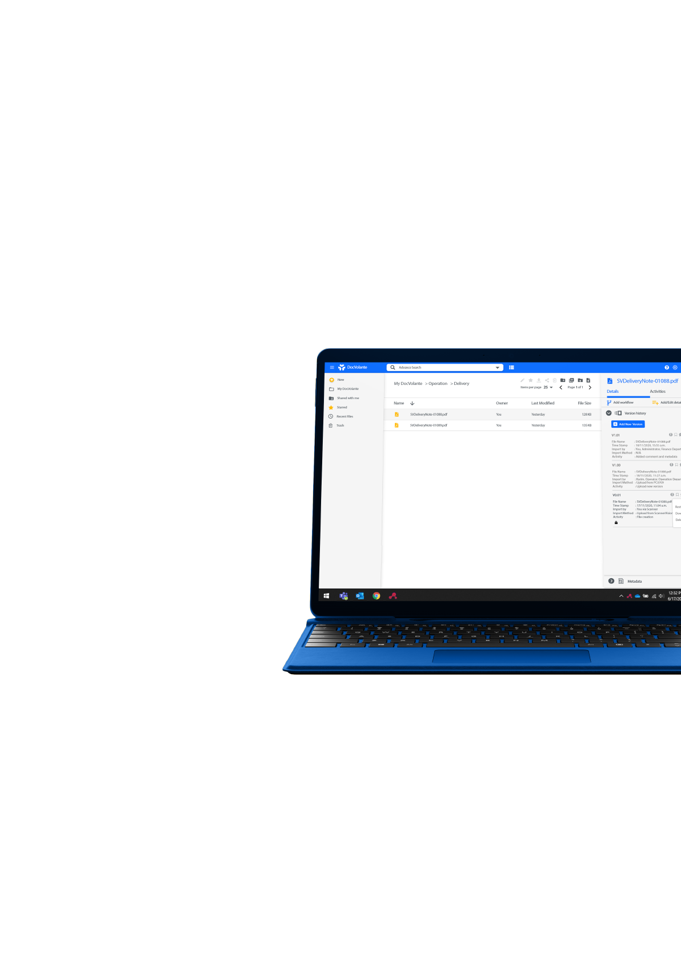

User
Manual
Admin Features

|Model Manager

Document Models are a way for documents to be classified in DocVolante. When a document has a Model assigned to it, it will have all the properties belonging to that model.
- Navigate to the model manager by clicking the gear icon in the top left corner
- Click on Model Manager on the dropdown menu

Creating and editing Document Types and their Properties
- Create a new custom type by clicking the “+” icon. The Custom Type window will pop up
- Enter a name for the custom type and click the “create” button

Creating /updating properties

- Creating properties
- With the Document Type created, you need to create properties that can be applied to the document
  - Each property can be customized according to the data expected. For example: where amounts are expected, the data type can be set to numbers only by selecting d:long as a data type
- Create each property and once done click the “Publish” icon to upload the newly created document types and properties to DocVolante
  - After clicking publish, a screen appears asking you to confirm your intentions to commit the changes to the server as Document Types cannot be deleted after they have been created.
- Update properties
- To update an existing property, simply select that property’s Document type, the list of properties will appear in the menu on the left, select the property you want to edit and click the edit tool (pencil) in the toolbar above.
- The Update Property pop up will open and here you can edit the property name, data type, constraints and more. Note: the ID of the property cannot be amended
- When done click “Update”.
- Click the “Publish” icon to sync the changes to DocVolante
  - After clicking publish, a screen appears asking you to confirm your intentions to commit the changes to the server as Document Types cannot be deleted after they have been created.

|License Manager
The License manager allows you activate your DocVolante license. When DocVolante is unlicensed, there’s a banner across the UI indicating it is unlicensed. When using a Not For Resales license, the banner will say “Not for Resale”. When using a production license, the banner will disappear.
- Navigate to the model manager by clicking the gear icon in the top left corner
- Click on License Manager on the dropdown menu
- Enter your license key
  - Click verify to see if the license is being used by another user
  - Click deactivate to deactivate the license
- Click Activate to enable the license on the DocVolante server
- The license details like expiration date and addons will be displayed on this screen once the license is activated.

|User Management
Upon installation, DocVolante will create a default admin user with username: admin and password: admin
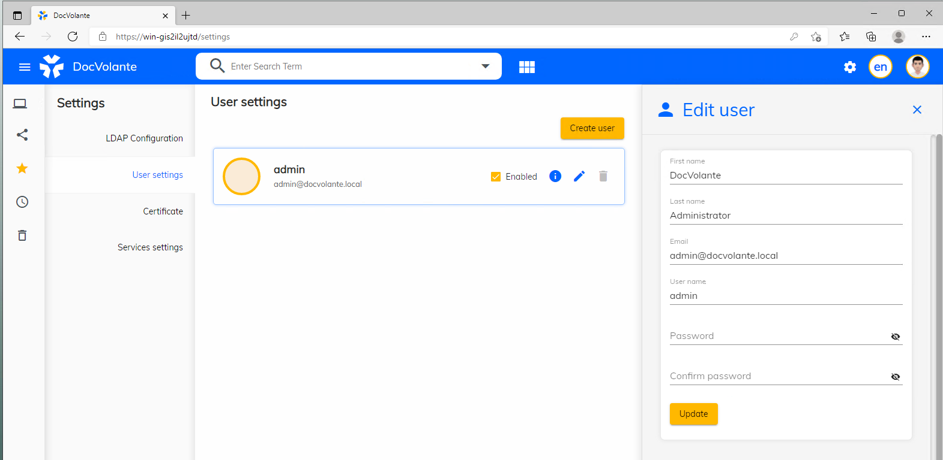
- Navigate to the model manager by clicking the gear icon in the top left corner
- Click on Settings on the dropdown menu
- Click on the User Settings tab

User Creation, updating, and deletion
When creating a new user all the fields should be filled. In an unlicensed DocVolante, the admin user can create users and but those users will not be able to login and use DocVolante.
User creation
- On the user settings tab, click create user
- The side menu on the right side of the screen will slide open, fill in the user credentials and click Create.
- When the user is created, they will appear on the main screen.
- To activate a user simply click the “enabled” option to activate this user.
User updating
- On the user settings tab, click the edit pencil icon next to the user you want to edit/update
- The side menu on the right side of the screen will slide open, change the settings you wish to update and click Update.
User deletion
- To delete a user simply click the trash can icon next to that user.
- You will be prompted to confirm your intentions and once you confirm that user will be deleted

LDAP User Import.
Please contact your administrator for Organization’s LDAP settings
- Navigate to the LDAP settings by clicking the gear icon in the top left corner
- Click on Settings on the dropdown menu

LDAP Settings
- On the settings screen, navigate to the LDAP Configuration tab
- Enter your LDAP configuration settings (Provided by your network admin)
- You can test the connection by clicking the Test Connection icon on the LDAP Configuration toolbar
- If the connection test result was successful, you enable the connection and clicking “Update Configuration”
- Your connection is now ready for use. You can click the Sync icon on the LDAP Configuration toolbar to either download the LDAP users or sync any updates.
- Once the import/Sync is complete; a pop up will be displayed on screen showing you a quick report of the sync results (eg: synced users, failed sync…)
Your LDAP configurations have been saved. You can sync users in DocVolante with the latest changes to users in LDAP by simply clicking the sync icon on the LDAP settings toolbar

|Certificate Management
DocVolante needs to work with an SSL certificate. During installation, a self-signed certificate is generated, and DocVolante uses it. This certificate can however be replaced with one from a Certificate Agency (CA)
- Navigate to certificates by clicking the gear icon in the top left corner
- Click on Settings on the dropdown menu
- Click on the Certificates tab

Importing and using new certificate
DocVolante allows you to import your organization’s certificate.
- On the Certificate screen click Select new certificate
- A browse window will open. Simply browse to where your certificate, select it and click Open.
- Your certificate will now be imported in DocVolante. To use it, restart the DocVolante Identity Service in Windows Services (Restarting the Identity Service will also restart the Content and the Web Services)

|Services Settings
The Services Settings tab allows you to change your current services settings
- Navigate to Services settings by clicking the gear icon in the top left corner
- Click on Settings on the dropdown menu
- Click on the Services Settings tab
Under this tab, you will see a full list of the DocVolante services in an accordion style display. Expend each service and go to its Update tab to make your changes and click Update to commit your changes.
After making changes to a service, it would need to be restarted in Windows Services

